

**PYTHON PROJECT REPORT (INT 213)**

**On**

**INVENTORY SYSTEM**

# ----------------------------------------------------------------------------

|  |  |
| --- | --- |
| **Name** | **: Anant Srivastava** |
| **Registration number** | **: 12004531** |
| **Roll Number** | **: RK20SDA26** |
| **Name** | **: Tejeshwar Dutta** |
| **Registration number** | **: 12004599** |
| **Roll Number** | **: RK20SDA25** |
| **Program** | **: B. Tech CSE** |
| **Semester** | **: Third** |
| **School** | **: School of Computer Engineering** |
| **Name of the University** | **: Lovely Professional University** |
| **Date of Submission** | **: 30th November 2021** |

**ABSTRACT**

Our project is a Bill Inventory System. It is a Inventory System

program written in python. User can use this inventory in their

computer.

The project is built from scratch and demonstrate the simple

billing system. In this project we can normally just add item

to the list by clicking on the checkbox according to the

customer and can generate the bill for them. The project also

compute the total amount of the purchase made by the customer ,

payable amount and the balance amount return to the customer.

**ACKNOWLEDGMENT**

We would like to express our special thanks to gratitude to our Prof. Upinder Kaur for giving us the opportunity to do this project on topic “ Inventory System ”, which also lead us to do a lot of research and we came to know about so many new things.

It helped us to enhanced our knowledge and skills.

**INTRODUCTION**

Customers might pay with cash, credit cards or an installment plan.

Regardless of how they pay, there is a need of a billing system to

invoice their orders.

Billing systems often are designed to handle everything from

computing charges to providing statements. billing system is the

process by which a business bills and invoices customers.

systems often include payment software that automates the

process of collecting payments, sending out recurring invoices,

**TEAM MENMBERS AND CONTRIBUTIONS**

* **Anant Srivastava**
* **Tejeshwar Dutta**

1. Coding ( Joined )
2. Information gathering ( Joined )
3. Report ( Joined )

**FUNCTION USED IN CODE**

1. **def print( )** : This function in code is used for generating bill

for the customer of the purchased item after clicking

on the Print button.

1. **def pay( )** : This function in code is used to display the balance

amount after clicking on PayNow button.

1. **def show( )** :This function in code is used to show the selected

item in the list after clicking on the Add button.

**FLOW CHART OF THE PROJECT**

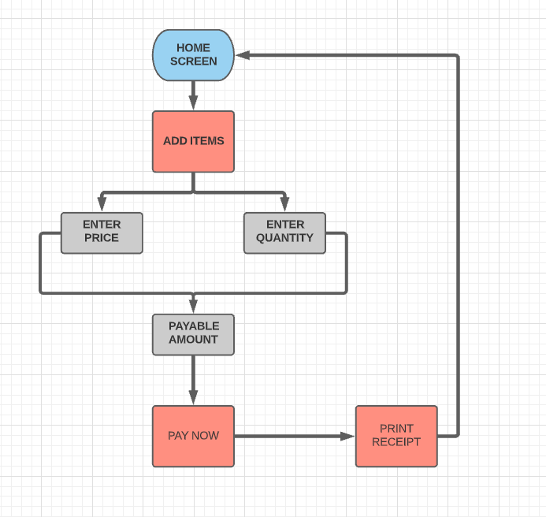

**SCREENSHOTS OF OUTPUT**

HOME PAGE:

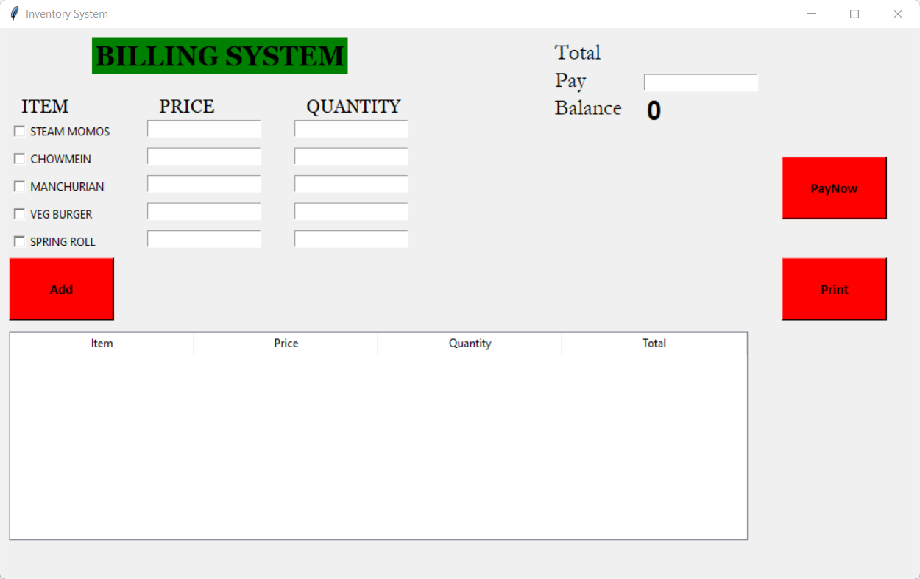

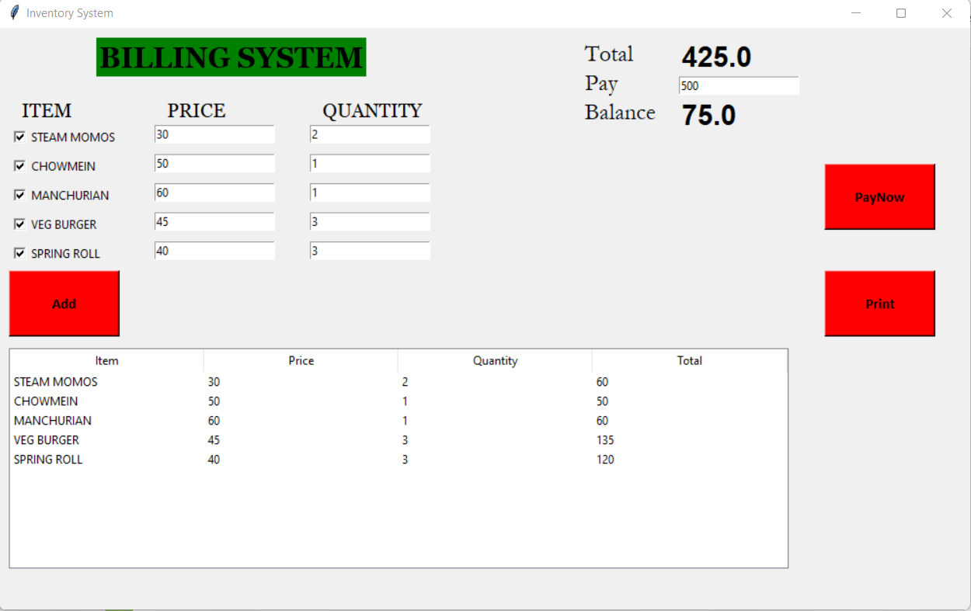

RECEIPT:

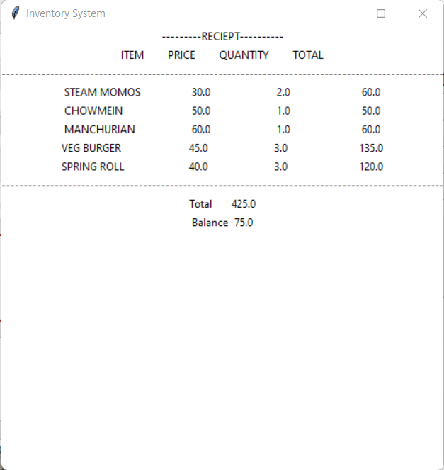

**SOURCE CODE:**

Source code is provided in below GitHub link:

**https://github.com/iTejeshwarDutta/Billing-Inventory-System**

**REFERENCES:**

1. https://www.tutorialspoint.com/python/python_gui_programming.htm
2. https://youtu.be/_PHJvjQJa3w
3. https://www.youtube.com/watch?v=VMP1oQOxfM0